K-W-L-D chart
Look at the chart with explanation of the chart
Fill in the information after viewing the video.

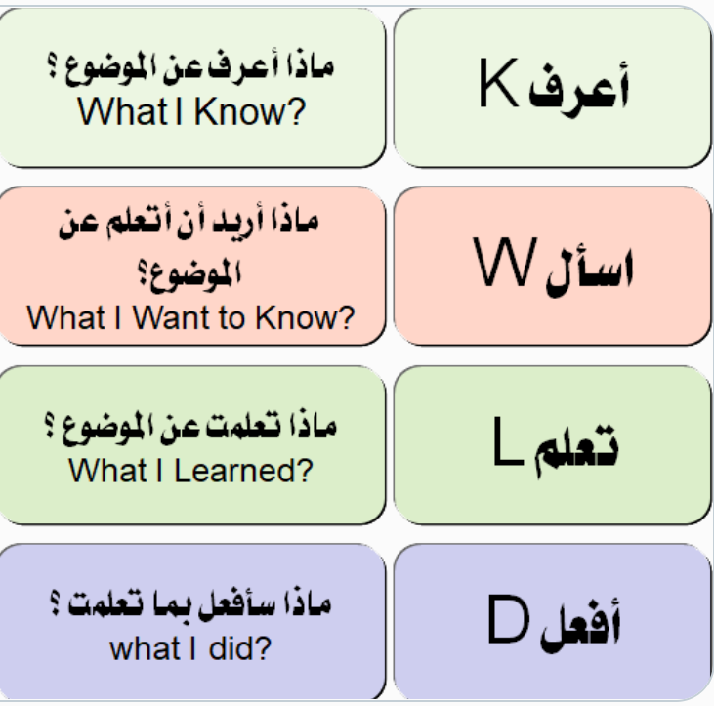
تعلمت\سأطبق | أسأل | أعرف

